William Colon

3-1

Marketing With ePortfolios and Artifact Update

**Part 1**

Using ePortfolios and hosting them on platforms like GitHub offers several advantages. They help keep projects organized and updated with timestamps, making it easy to track changes. This organization allows employers to easily navigate different repositories to see modifications. Additionally, ePortfolios serve as a backup to recover lost work. It's also crucial to showcase my proficiency in various programming languages by setting the repository language, demonstrating my skills in Python, Java, C++, and more. Lastly, I can conveniently share my work with employers by providing my GitHub link, whether during in-person interviews or virtual meetings.

While ePortfolios have advantages, they also have drawbacks. One issue is the risk of data corruption from external sources and a lack of understanding about ePortfolios. Without proper security, a project’s main.cpp file can be vulnerable online. Fortunately, GitHub offers safety features that make projects read-only and secure, with options to set repositories to private. Additionally, many businesses and employers lack the knowledge to effectively use or understand ePortfolios when hiring new employees.

**Part 2**

* Software design and engineering

My project incorporates numerous files from libraries into the main.cpp file for design purposes. For instance, shader files are essential for creating 3D objects, and without them, the program encounters a GL error. To keep track of these shader files, I organized them into a folder within the main project, making them accessible to anyone using the project. Additionally, I included an image folder containing jpg and png files to provide the necessary textures for the 3D designs.

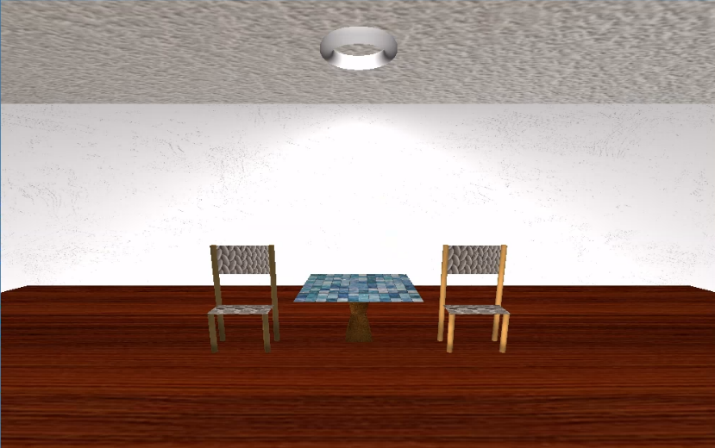

* Algorithms and data structures

I enhanced my project by incorporating new algorithms and data structures to improve the design. I updated the camera.h file to enable vertical camera movement using the Q and E keys on my keyboard, utilizing commands from the GLFW library. I incorporated data structures like staticMesh3D.cpp and header files, as well as vertexBufferObject.cpp and header files, to enhance the graphics of images in my 3D design.

* Databases

Worked with MongoDB and learned how to connect, import, create, delete create a Python testing script in Jupyter Notebooks that imports the CRUD Python module to call and test the create and read instances of CRUD functionality.

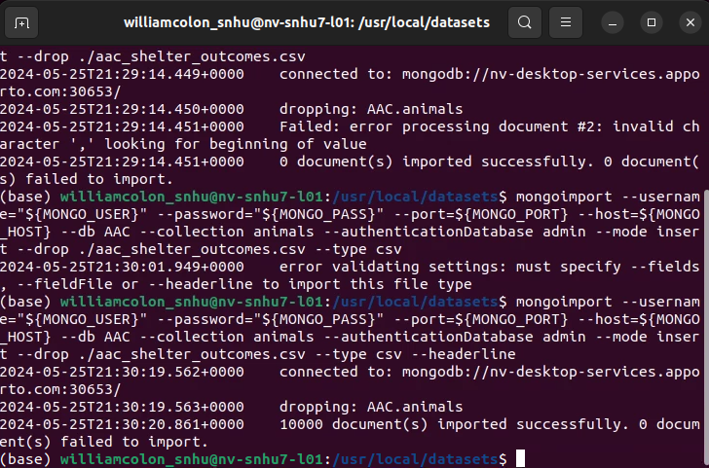

<https://github.com/williamcolon/IT-499-Code>